BLG336E – Analysis of Algorithms II Homework 2 Report

Talha Çomak

150160726

In this homework i used dijkstra algorithm. This algorithm finds the shortest path. The aim of this homework is understand to dijkstra algorithm. In this homework it is asked to show all nodes on the shortest path. And also checking fort the conflicts between Lucy and Joseph at the same time. To find the conflicts i wrote two metods *conflictCheckerDest* and *conflictCheckerRet*. One of them checks before the destinations. The other one checks after the destinations. I also explained my code with comments.

The outputs of tests:

Test1:

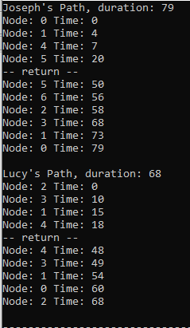

Test2:

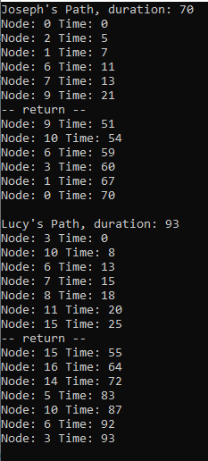

Test3:

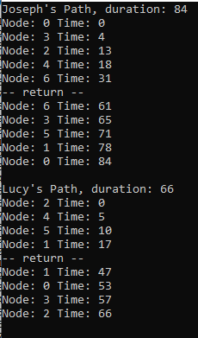

Test4:

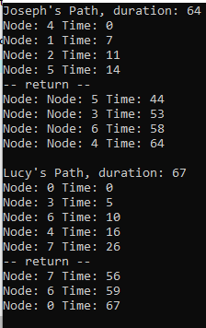

Test5:

D:\D\Dersler\algo2\Ekran Alıntısı5.PNG